APSACS SUMMER FITNESS PLAN FOR SESSION 2024-25
The summer vacation period provides an excellent opportunity for students to focus on their physical, mental, and emotional well-being through engaging in various home chores & physical activities. This comprehensive fitness plan aims to cater to students aged 3 to 16, addressing their diverse needs and interests while promoting a balanced approach to health and fitness.
- Instructions for School Administration. A school-based help / guidance must be provided for a more holistic experience for pupils. The School Administration is therefore required to engage their PTIs/Coaches/Physical Trainers of their respective school, during summer holidays, through WhatsApp groups. Students can share/submit the videos & photographs of their activities through this platform.
- Instructions for Parents
- Make the given activities a part of daily routine. From household chores to an after-dinner walk, keep your family active every day.
- Most of your child’s 60 minutes of daily physical activity should be aerobic activities, like walking, running, or anything that makes their hearts beat faster. This is important as cardio exercises help strengthen the heart muscles.
- Limit time spent in sedentary activities, such as watching TV, using electronic devices, being online, and playing video games.
- Take advantage of local playgrounds/parks. Make family fitness outings part of your regular routine. Let family members choose an activity — go hiking or try out the rock-climbing gym. Anything goes, as long as everyone can participate.
- Provide nutritious snacks and plenty of water throughout the day to support energy levels and hydration.
- Encourage healthy eating habits by offering a variety of fruits, vegetables, whole grains, and dairy products.
- Ensure sun safety measures are in place during outdoor activities, including playtime during cooler hours of the day to minimize sun exposure and risk of heat-related illnesses.
- Maintain a flexible schedule that allows for a balance of active play, structured activities, and rest time throughout the day.

- Advantages
- Through physical activities, kids learn about sportsmanship, setting goals, meeting challenges, teamwork, and the value of practice.
- Kids 6 to 8 years old are sharpening basic physical skills like jumping, throwing, kicking, and catching. Some enjoy doing this in organized sports teams, but non-competitive leagues are best for younger kids. Show your support by coaching your child's team or cheering from the stands on game days.
- Kids 9 to 12 years old are refining, improving, and coordinating skills. Some become even more committed to a sport while others drop out as competition heats up and level of play improves.
- Precautions
- Kids who participate in sports are at risk for injuries, so be sure yours wear the proper protective equipment, such as a helmet and protective pads etc.
- A child with a chronic health condition or disability should not be excluded from fitness activities. Some activities may need to be changed or adapted, and some may be too risky depending on the condition. Talk to the doctor about which activities are safe for your child.
- Kids who enjoy sports and exercise tend to stay active throughout their lives. And staying fit can improve how kids do at school, build self-esteem, prevent obesity, and decrease the risk of serious illnesses such as high blood pressure, diabetes, and heart disease later in life.

SELECTED EXERCISES FOR KIDS TO DO AT HOME

For Preschoolers

The early years of childhood are crucial for the development of physical, mental, and emotional well-being. This comprehensive fitness plan is designed specifically for students aged 3 to 5 during their summer vacations, with a focus on fostering holistic growth and creating a nurturing environment for exploration and play.
Physical Fitness:  - Outdoor Playtime:  - Encourage outdoor playtime in safe environments for at least 1 hr daily.  - Provide access to playground equipment such as swings, slides, and climbing structures to promote gross motor skills development.  - Active Games and Activities:  - Organize age-appropriate games and activities that promote movement and coordination, such as tag, follow the leader, and obstacle courses.  - Incorporate simple exercises like jumping jacks, hopping, skipping, & stretching into daily routines.  - Nature Walks and Scavenger Hunts:  - Take students on nature walks or scavenger hunts in parks to encourage exploration and sensory stimulation.  - Encourage observation of plants, animals, and natural phenomena to foster curiosity and appreciation for the environment.  Mental Strength:  - Storytelling and Imagination Play:  - Engage child in storytelling where they can use their imagination to create and act out stories.  - Provide props, costumes, & puppets to enhance creative expression.  - Educational Games and Activities:  - Introduce age-appropriate games and activities that promote cognitive development, such as shape sorting, counting games, & puzzles.  - Incorporate learning concepts such as colors, numbers, letters, & shapes into daily play activities.  - Arts and Crafts:  - Provide opportunities for arts and crafts activities such as painting, drawing, coloring, & crafting with various materials.  Emotional Well-being:  - Emotion Recognition and Expression:  - Let child recognize and express his / her emotions through simple activities such as storytelling, role-playing, & puppet play.  - Mindfulness and Relaxation:  - Create calming spaces or quiet corners where child can retreat for moments of relaxation and reflection.  - Social Interaction and Friendship Building:  - Encourage sharing, and collaborative play to foster empathy, cooperation, and friendship skills. |  | 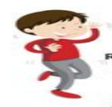  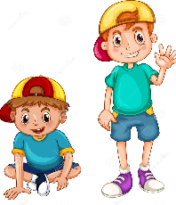  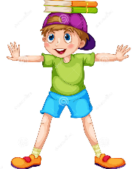  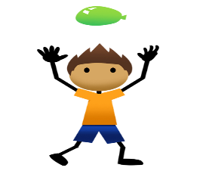  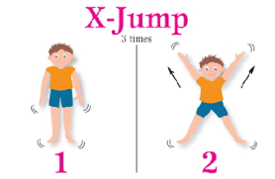  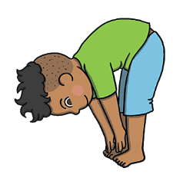  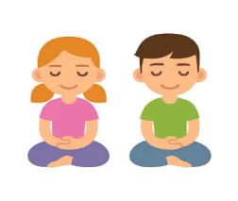  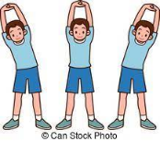  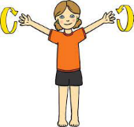
Recommended activities with guided Instructions
Running | Run in a shaded place for 5 min, each day.
Sit & Stand | Do sit & stand, 10 times a day, inside your home.
Balance a book | Balance 2 books on your head for 2 minutes, daily
Balloon Flash  (optional) | Keep the balloon in air without touching the ground. Hit the balloon with head only, to keep in air for 2 minutes.
Jumping Jack | Jump for 5 times, daily
Touch your Toes | Stand up & then touch your toes for 10 times, every day.
Yoga | 5-minute yoga in any posture, every morning.
Hands over Head | Stretch your hands over your head for 2 mins, daily
Forward & Backward | - Arm Circles forward for 30 sec  - Arm Circles backward for 30 sec

For Junior & Middle Section

This comprehensive fitness plan is designed to provide a balanced approach to health and fitness while catering to the diverse interests of students in this age gp.

Physical Fitness:
- Structured Physical Activities:
- Organize physical activities and outdoor adventures.
- Offer a variety of activities to cater to different interests, including basketball, swimming, cycling, hiking.
- Daily Exercise Routine:
- Follow a daily exercise routine that includes cardiovascular exercises, strength training, and flexibility exercises.
- Active Playtime:
- Allocate time for unstructured playtime where students can engage in active play and free movement.
- Provide access to playgrounds, sports equipment, and open spaces to run, jump, climb, and play games with siblings / peers.

Mental Fitness:
- Educational Enrichment Activities:
- Offer enrichment activities that stimulate critical thinking, problem-solving, and creativity.
- Include activities such as science experiments, coding workshops, art projects, and storytelling sessions to engage students' minds and encourage exploration.

- Reading and Literacy Programs:
- Encourages reading independently or participate in read-aloud sessions.
- Provide access to a variety of books and reading materials to cater to different interests and reading levels.
- Brain Teasers and Puzzles:
- Introduce brain teasers, puzzles, and logic games to challenge students' cognitive skills and keep their minds sharp.
- Include activities such as crossword puzzles, Sudoku, riddles, and memory games to promote problem-solving and memory retention.

Emotional Well-being:
- Mindfulness and Relaxation Practices:
- Encourage regular practice of mindfulness exercises to reduce stress, improve focus, and enhance emotional regulation.
- Expressive Arts Therapy:
- Provide opportunities for artistic expression through visual arts, music, drama.
- Encourage students to express their thoughts, feelings, and experiences through creative outlets to promote self-awareness and emotional expression.
- Social and Emotional Learning Activities:
- Include activities such as role-playing, cooperative games, team-building exercises, and peer discussions to foster positive relationships and emotional intelligence.

Recommended activities with guided Instructions
Cl I-V
Home Chores
According to research, doing age-appropriate chores is vital at all childhood stages, even for children as young as three. That’s because household chores boost kids’ sense of responsibility.
Tidy-Up Room | - Encourage your children to keep their room clean. Help them organize their toys and make their bed.  - Clean out the trash, teach the importance of throwing garbage in trash can
Clean Meal Table | - Cleaning a table after meal is one of the simplest yet most important chore.  - Ask your kids to clean table after meal time while you are picking cookware and transporting it back to kitchen
Setting Book Stand | - Help your kids to sort books via authors or alphabetically.  - Also always encourage them to keep their study tables, books and bags in a perfect order
Organize Their Toys | - Always take time out with your kids each week to sort toys.  - Let them keep only those toys in their room for each week which they’ll be really using.
Physical Fitness
- 5 x min warm up activity must be practiced before starting any physical activity.
- At least 3 x activities to be performed on daily basis (recommended an 30-40 min of physical activity every day for their overall healthy body).
- Time Duration and number of steps can be reduced or increased as per the stamina and physical fitness of the child.
- Parents are requested to supervise their children during physical exercises.
Stretching | - Stretches to try include side stretch, hamstring stretch, fingers-to-toes, arm circles, arms to the sky, calf stretch, and runner's stretch.  - A stretching sequence and cool-down helps transition kids into a more relaxed state post-workout.
Cycling  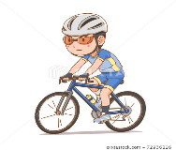 | - Find a suitable location to cycle, far from traffic.  - Wear the correct riding gear, covered shoes, knee, and elbow pads.  - Wear a helmet. Cycle during the daytime or afternoons and not after dark
Skipping  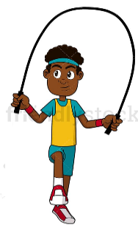 | - Choose the right rope — one that’s not too long - reaches nearly the shoulders when folded in half.  - Stand up and hold the rope handles in both hands.  - Extend the hands and forearms a foot away from the body at an angle of 45°.  - Step over the rope; the rope will hang behind.  - Hop over when the rope comes towards the front of the feet. Use the ankles, but do not bend the knees, to jump.
Running  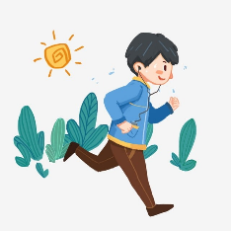 | - Warm-up with jumping or doing arm swings.  - Look ahead on the ground to avoid tripping.  - Keep the feet pointed straight ahead.  - Keep the hands at the waist level while running. The hands and arms should be as relaxed as possible while running.  - The postures — head high, back straight and level, shoulders should be relaxed
Jumping  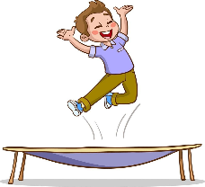 | - Jump straight up, then cross one foot in front of the other; on next jump, switch feet and continue.  - Jump side-to-side or front-to-back over a pretend hurdle.  - Stretch arms and legs out to the side like a starfish while jumping; on the second jump, return arms to sides and legs to center on the landing.
Indoor Ball Games  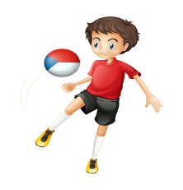 | - Tossing balls into laundry baskets  - Hitting balls at a target with a stationary object  - Catching balls with a plastic mixing bowl  - Throwing, rolling, or kicking a ball against the wall
Recommended activities with guided Instructions
Cl VI-VIII
Home Chores
At this stage, children are practicing to take care of others and caring for themselves. Learning social responsibility and self-care helps increase teens’ and tweens’ self-esteem and gives them skills they can use throughout their lives.
Tidy-Up Room | - Encourage your children to keep their room clean. Help them organize their toys and make their bed.  - Clean out the trash, teach the importance of throwing garbage in trash can
Dusting
Grocery Shopping | - Ask them to choose what vegetables or fruits would they like to have and let them choose these themselves.  - If they pick anything that is unhealthy, tell them why it’s not recommended.  - This will also encourage excitement for healthy food and food choices.
Fold Laundry | - Children can help to fold small clothes like socks, handkerchiefs, vests, under-garments and any small clothing.  - They will feel involved and will develop the habit of folding laundry which otherwise seems like a herculean task
Wash Dishes | - Let the child help parents with rinsing dishes first, then move on to washing less dirty items like glasses or cups.  - As they get comfortable, they can start tackling plates, bowls, and eventually pots and pans.
Taking out the garbage and recycling
Making simple foods (toast, cereal)
Physical Activities
- 5 x min warm up activity must be practiced before starting any physical activity.
- At least 3 x activities to be performed on daily basis (recommended an 30-40 min of physical activity every day for their overall healthy body).
- Time Duration and number of steps can be reduced or increased as per the stamina and physical fitness of the child.
- Parents are requested to supervise their children during physical exercises.
Stretching  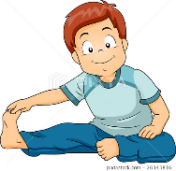 | - Sit with the back straight. Stretch both the legs as wide as comfortable.  - Hold the right knee with the right hand.  - Lift the left hand to the top of the head and lean towards the right.  - While leaning rightwards, stretch the left part of the body as comfortably as you can. Keep breathing.
Jogging | - Find a safe route to jog.  - Wear comfortable clothes and shoes.  - Start with a warm-up before jogging.  - Pick up a slow but good pace.  - Keep the head straight and look ahead.  - Don’t hunch the shoulders; keep the hips stable and don’t let them swing.
Overhead Shoulder Stretch  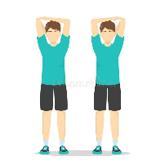 | - Stand straight with the shoulders slightly stretched back, feet shoulder-width apart, and chest forward.  - Raise the left arm over the head, bending the elbow and placing the hand behind the neck.  - With the right hand, grasp the left elbow and gently give it a pull behind the head.  - Relax the body, repeat with the other arm.
Planks  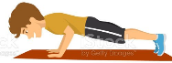 | - Rest the forearms on the ground. Keep the arms parallel to the body at a shoulder-width distance.  - Look at a spot on the floor to have the spine and neck neutralized. Keep the head in line with the back.  - Slightly lift the legs and the core a little upwards with the tip of the toes on the ground and hold it.
Push-Ups  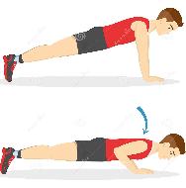 | - Lie face-down on the floor. The hands are to be palms-down on the floor.  - Raise the body using the arms, with weight supported by the hands and the balls of the feet.  - Go down by lowering the torso on the ground, as the elbows make a 90° angle.  - Repeat this lowering and lifting steadily, if you are comfortable
Crunches  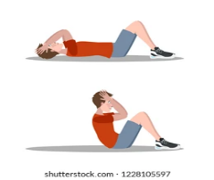 | - Lie flat on the floor with feet hip-width apart. Keep the knees bent.  - Interlace the hands behind the head, with the thumbs behind the ears.  - Start pulling the abdomen inwards gently. Curl up by lifting the neck, head, and shoulder blades off the ground.  - Hold the posture for a moment and lower the body to the ground, slowly.
Forward Lunges  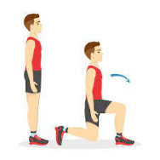 | - Stand with feet hip-width apart and keep the back straight.  - Move the right leg forward and lean the body ahead — 70% of the bodyweight will now be on the front foot.  - Lower the body until the right knee makes a 90° angle. Keep the back straight.  - The lower leg must be parallel to the ground, and the thighs perpendicular.
Bridge Lift  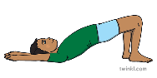 | - Lie flat on the back; keep the hands on the sides, and the knees bent.  - Place the feet shoulder-width apart.  - Pushing the body with the heels, lift the hips off the ground while keeping the back straight.  - Breathe out and hold the position for about one second.  - Come back to the initial position while breathing in.
Squats  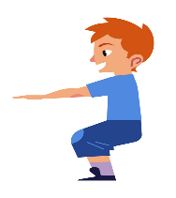 | - Keep the feet shoulder-width apart.  - Bend the knees like sitting on a chair while holding the heels on the ground.  - While doing this, pull in the abs and keep the back straight.  - Push the hips back and lower as much as it’s comfortable.  - Inhale while lowering and exhale while rising.

REPORTING FORMAT
(Physical Activities performed during summer holidays)
(to be submitted to Class Teacher after vacations)
Week | Monday | Tuesday | Wednesday | Thursday | Friday | Saturday
1
2
3
4
5
6
7
8

REPORTING FORMAT
Home Chores I Have performed, this Summer
(to be submitted to Class Teacher, after after vacations)

Name: _____ Class:_____________

